Participative Session Planning Tool
V0.2

Developed by Tim Davies,
(www.timdavies.org.uk)
of
Practical Participation
www.practicalparticipation.co.uk
tim@practicalparticipation.co.uk

This document includes:

1. A blank copy of the session planning tool.

2. A worked example of how the tool can be used.

Please send any feedback, suggested changes or other comments on this tool to the address above.

This document is licensed under the Creative Commons ShareAlike 2.0 UK: England & Wales license.

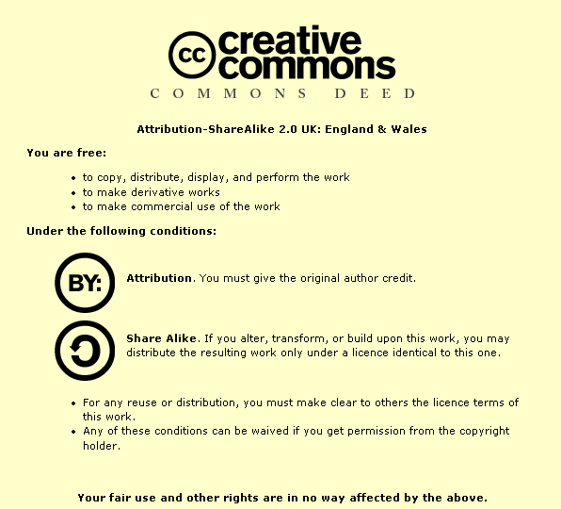

For the full license see: http://creativecommons.org/licenses/by-sa/2.0/uk/legalcode

Participative Session Planning Tool
This tool is designed to help you think about planning a focused session with young people or community groups. A session may be stand-alone, or may be part of a longer process, day or residential. It encourages you to think about the purpose of the session; the information and understandings of context that participants need in order to make informed decisions; and how you come to a group decision that everyone understands and can move forward from.

You should aim to fill in all those boxes that are relevant to you. You may wish to brainstorm ideas for each of the sections first, before writing down your final plan. Prompts are included to help you identify what an entry into each box might start with.

Need to do (session aim):  - What decision do you want to have made by the end of the session?  - What is your aim for the session? How does this fit with your aims and objectives for your whole process / event? | By the end of this session we will have...
How long? How many?  - How long do you have for the session? How many people are involved? | Our session is ......... long  There will be .......... people taking part who are.....
Need to know:  - What do participants need to know or understand in order to contribute effectively to your aims and ‘action’ outlined above?  - If you were making the decisions needed as part of this session, what information would you be using – even implicitly? | To make sure everyone can influence our decisions, and that we successfully reach good decisions participants will need to know..........
Giving Context:  - How will you share this necessary background information, knowledge and understanding with participants?  - How will you make sure that they have the opportunity to share their own relevant knowledge and understanding? | Participants will get the chance to understand the context of decisions through.....
Making Decisions
- How vital is it that you make decisions in this session (rather than solely exploring ideas)?
- Does everyone need to support the decision? Does there need to be consensus? Do those who disagree with the decision still need to be able to work with it?
What are you going to do?
Fill in your full session plan overleaf and use this to run your session…

Session Name:
Time | Activity | Who | Resources
E.g: 4.00-4.10 | Introductions  Throw a ball around the room. When anyone catches the ball they introduce themselves…. | Dmitri | (soft!) ball

Evaluation
- Fill this in after the session…
- What worked in the session?
- What didn’t?
- Did everyone feel they had the information they needed to make an effective decision?
- Could everyone consent to the outcome of the decision?
- What could be improved on next time?

Participative Session Planning Tool: Worked Example
This is a worked example of the Participative Session Planning Tool.

The example is developed for an imagined group of school based young campaigners setting up a new campaign.

Need to do (session aim):  - What decision do you want to have made by the end of the session?  - What is your aim for the session? How does this fit with your aims and objectives for your whole process / event? | We need to choose what we will campaign on this term and we need a name for our campaign. We also need to know who is interested in organizing the campaign actions.  We need to know what our campaign is before we can get funding from the school council this year. When we set up our group we decided on our ‘vision’ and so what we choose to campaign on must fit with our vision.
How long? How many?  - How long do you have for the session? How many people are involved? | The session is 1 hour 30 minutes long. There are usually about 10 people at the meetings and for some people this will be their first meeting with the group.
Need to know:  - What do participants need to know or understand in order to contribute effectively to your aims and ‘action’ outlined above?  - If you were making the decisions needed as part of this session, what information would you be using – even implicitly? | We need to know about each other…  Everyone needs to know our ‘vision’. We agreed this at the start of term last year.  It is helpful if people know what we have campaigned on in the past. People need to know something about how our campaigns usually work (what we do, when, how etc…) - but we want to hear people’s new ideas as well for how we could improve them…  We can be more effective if we know what decisions the school might be taking this year, and who is taking them…  We need to know about funding and resources. How much can we get and how can we get it?
Giving Context:  - How will you share this necessary background information, knowledge and understanding with participants?  - How will you make sure that they have the opportunity to share their own relevant knowledge and understanding? | We need an ice-breaker / introduction activity that helps us find out about each other.  We can put our vision on the wall on a flip-chart and mention it when starting.  We could put up photos of what we have done in the past and someone from the group can talk us through them. We can ask everyone who has been involved before to bring photos…  We can ask the School Council link-person to tell us what decisions the school might be taking this term.  We can have a resource wall where we put information about resources we think we might have access to – including funding…
Making Decisions  - How vital is it that you make decisions in this session (rather than solely exploring ideas)?  - Does everyone need to support the decision? Does there need to be consensus? Do those who disagree with the decision still need to be able to work with it? | We must decide on the campaign in this session – otherwise we’ll miss the deadline to apply for funding!  We should try to get everyone to agree on the name – as if we don’t then a few of us might have to get together and decide it on your own…  If people don’t agree with the result then they probably won’t get involved with the campaign… so the more people who agree the better, but it isn’t the end of the world if some people disagree…

What are you going to do?
Session Name:
Time | Activity | Who | Resources
3.55-4.00 | Set Up  Before everyone arrives set up all the chairs in a circle and put refreshments on a table at the back. Put photos on the walls, and put our vision on the whiteboard. | Everyone | Whiteboard pens  Blutac
4.00-4.10 | Introductions  Throw a ball around the room. When anyone catches the ball they have to say:  - Their name  - Their favorite band, tv program or website  - Why they have come to the meeting today  (One of us should start so that people get the idea of what sort of thing they should say. We could start throwing the ball around before people arrive so that when someone comes in they can get involved straight away and they don’t have to stand around if they don’t know anyone…) | Dmitri | (soft!) ball
4.10-4.20 | Refreshments and Photo Wall  We’ll have some refreshments (energy food that will keep us alert!) and then we’ll encourage people to look at the photos on the wall… (if we can borrow a video projector then we could have them looping as a slide show). | All | Fruit juice,  Dried fruit
4.20-4.35 | The History  As soon as everyone has got drinks, we can stand around the photos and James (chair of the campaign group) can explain what they show from the history of the group. He should talk about:  -What we did  -When we did it  -Why we did it  There should be time for people to ask some questions…  The School – Update  Darshna (school council link person) can tell us quickly about the things the school is planning to do this term… and the decisions they might be making… | James  Darshna | Photos  Notes for speaking…
4.35-4.55 | Campaign Ideas – What do you care about?  Split everyone into small groups (2-3) and ask them to talk about the issues they care about in the school. They should write them on post-it notes.  After 5 minutes, start asking people to feedback the issues they care about to the whole group. Everyone should bring their post-it notes and stick them on the whiteboard in groups with similar issues. We can draw circles round the issues to group them together… | Rachel | Post-it notes (interesting shapes and colours!)  Whiteboard Pens
4.55-5.00 | Choosing our issue  Tell everyone that they have three positive votes (crosses with the green whiteboard pen) and one negative vote (cross with the red whiteboard pen). Get everyone to come up to the board and vote for (or against) the issues they think we should work on (they can use all their votes on one thing, or spread them out…) | James | Red and green whiteboard pens
5.00-5.10 | The decision  If there is a clear vote, then we have decided on our campaign ☺. If not, then we might need to all talk about it a bit more and shuffle the session plan back 10 minutes (we’ll have to forget about the name for now in that case ☹)  Planning  When we have a decision then we should get everyone to call out their ideas of what we should do as part of the campaign and we should put these on a flip-chart. This will help keep people enthusiastic about the idea, even if we don’t have time to go in-depth into these issues now. | Ask the supporting teacher to run extra discussions...  James | Flip charts and pens
5.10-5.20 | What we need  Explain to everyone that at the next meeting we will bring out the flipchart we have just created and will choose which actions to take when. Explain that we need to think about the resources we might need for our campaign and that we need to tell the school council that we need some funding for things.  Ask everyone to think about other resources we might need, or resources we might already have. Ask everyone to write their ideas on post-it notes and put them into ‘Wanted’ and ‘Have’ columns on the wall…  When people have mostly done this, ask about any missing details – like when someone writes ‘we need money’ – ask if they have any ideas how much money? Get everyone to join in thinking about it | James & Darshna | Post-it notes for resource wanted and haves to be written on.  Flip chart / cards to put up ‘Wanted’ / ‘Have’ headings on the wall
5.20-5.30 | Deciding on the Name  Flip-chart idea storm of names…  Quick dot-voting again to decide on our favorite.  Check with everyone that the vote winner really is the favorite. | Dmitri | Flip chart and pens
5.30 | Closing  Quick sum-up of everything we’ve decided and make sure people know about the next meeting.  Check we’ve got everyone’s e-mail address and form group… | Dmitri | E-mail sign-up sheet  (make sure we pre-print all the people we have details for on the sheet)

Evaluation  - Fill this in after the session…  - What worked in the session?  - What didn’t?  - Did everyone feel they had the information they needed to make an effective decision?  - Could everyone consent to the outcome of the decision?  - What could be improved on next time? | Everyone took part really well. The ice-breaker game was good fun and we found out about each other well.  The photos were too small – we should have blown them up onto A4…  Almost everyone seemed to stay focused, but two people didn’t seem to understand what our group is about. Perhaps we need to prepare a leaflet that people can read when they arrive or beforehand.  We didn’t have enough time to decide on a name – and voting on peoples ideas straight away without time for people to think about things upset some people when their ideas didn’t get any votes and they felt they hadn’t had time to justify things.  We should maybe have refreshments a bit later so people can talk over refreshments about the ideas they are having, rather than listening to a talk over refreshments when they can be a bit distracted.

